**Title**

**First Name LAST NAME1*, First Name LAST NAME1, First Name LAST NAME2**  
1Name of the Organizational Unit, Full Address  
2Name of the Organizational Unit, Full Address  
*Email address

The abstract should fit on a single B5-sized page (17.6 x 25 cm) and briefly present the topic of the paper, its objectives, and the scope of the conducted research, as well as the most important results and conclusions.

The document should be prepared in Microsoft Word (.docx) format using MS Word 2007 or later. You can use the template.docx file as a formatting guide.

The title should be written in bold Arial font, size 14 pt, with 6 pt spacing before and after the title. Authors' names should be in bold Arial font, size 10 pt, with surnames in uppercase letters. Affiliations should be written in Arial font, size 9 pt. The text of the abstract should be in Arial font, size 10 pt, justified on both sides. Document margins should be set to 2.0 cm. Paragraph spacing should be 6 pt.

Mathematical formulas should be centered, with numbering aligned to the right, as shown in the following example:

 ${∆λ}_{eff}[nm]=\int{\frac{I(λ)}{I_{max}}}dλ$ (1)

Figures and charts should be centered as objects. Captions should be centered below the figure, written in bold Arial font, size 9 pt.

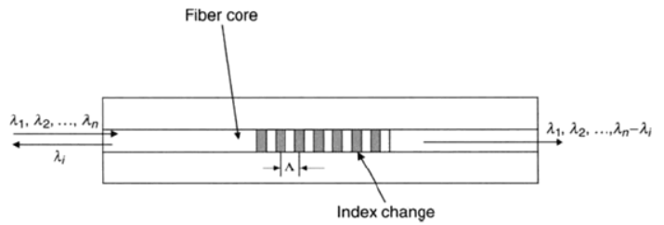

**Fig. 1. Sample figure caption**

References

1. N. Last Name, N. Last Name, *Title of the Book*, Publisher, Location, Year.
2. N. Last Name, *Title of the Article*, Proceedings of SPIE 55 (2015) pp. 24-29.