Title
Name Surname¹*, Name Surname², Name Surname³
¹Department, Institute, Faculty, University
²Department, Institute, Faculty, University
³Department, Institute, Faculty, University
*e-mail
Abstract: Maximum 400–600 characters. The abstract and keywords should be prepared in English, regardless of whether the publication is in Polish or English.
Key words: keyword 1, keyword 2, keyword 3, keyword 4, keyword 5

Introduction
The paper should contain 10,000–20,000 characters. Double spaces, as well as unnecessary spaces before commas, full stops, etc., should be removed. The following elements must not be left at the end of a line: titles preceding surnames, initials placed before surnames, Arabic and Roman numerals, abbreviations (e.g., i.e., e.g., etc.), as well as conjunctions and prepositions (e.g., and, or, of, in, on, at, to, by). A uniform citation system must be applied throughout all chapters, i.e., references should be made to the appropriate numbers in the bibliography rather than to the author’s name(s) and year of publication [1]. If referring to multiple works, all relevant publications should be cited [2–5].

1. Title of chapter 1
The use of bullet points in the following format is recommended [6]:
- Text,
- Text,
- Text,
- Text,
- Text.
Equations should be numbered as shown in the example — in round brackets and aligned to the right. Formulas and equations must be placed in the text on separate lines. Explanations of the symbols used in the equation should be provided directly below the formula:
$P_{R}= \frac{λ^{2}}{{\left(4πd\right)}^{2}}G_{T}P_{T}G_{R }$ (1)
where:
PR – text,
GT and GR – text,
PT – text,
λ – text,
d – text [11].

2. Title of chapter 2
Figures should be inserted and formatted to ensure readability. Figures must be numbered consecutively. Do not place a full stop at the end of figure and table titles. A full stop is needed after the source. Care should be taken to use mathematical symbols whenever possible, rather than letters; for example, do not use "x" when describing dimensions, e.g. 5 × 5 m. For graphics, preferably use vector files (CDR, EPS, SVG), Word or Excel charts, or 300 dpi CMYK bitmaps at a 1:1 scale.
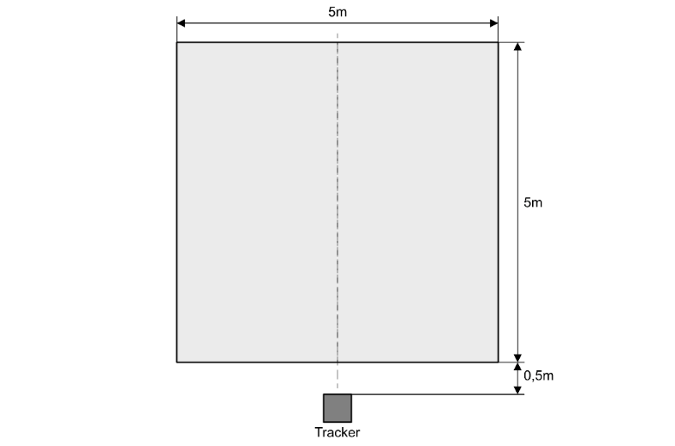
Figure 1. Scheme of the of the reference system relative to the working area
Source: own studies.
It is recommended not to split tables.
Table 1. Zestawienie wartości średnich błędów najlepszych modeli
Weights | k | Mean error | Mean error | Mean error
Weights | k | [m] | [m] | [m]
Distance | 7 | 2,34 | 1,63 | 1,33
Uniform | 1 | 2,45 | 1,71 | 1,45
Source: own studies.

Summary
The list of references should be included at the end of the publication. Detailed guidelines for creating a bibliography in the APA style can be found on the official website: https://apastyle.apa.org. Examples of how to cite specific types of sources can be found on the subpage https://apastyle.apa.org/style-grammar-guidelines/references/examples.

Acknowledgment
This work was supported by the institution, project no.

Literature (if the chapter is prepared in English)

Journal article in which the articles are numbered:
[1] Leitch, S. G., Ahmed, Q. Z., Abbas, W. B., Hafeez, M., Laziridis, P. I., Sureephong, P., Alade, T. (2023). On indoor localization using WiFi, BLE, UWB, and IMU technologies. Sensors, 23(20), 8598. https://doi.org.10.3390/s23208598

Journal article with page range specified:
[2] Zafari, F., Gkelias, A., Leung, K. K. (2019). A survey of indoor localization systems and technologies. IEEE Communications Surveys & Tutorials, 21(3), 2568–2599. https://doi.org/10.1109/COMST.2019.2911558

Preprint:
[3] Kulozik, J., Jarrassé, N. (2024). Evaluating the precision of the HTC VIVE Ultimate Tracker with robotic and human movements under varied environmental conditions. arXiv:2409.01947. https://doi.org/10.48550/arXiv.2409.01947

Online source with a known publication date:
[4] Carey, B. (2019, March 22). Can we get better at forgetting? The New York Times. https://www.nytimes.com/2019/03/22/health/memory-forgetting-psychology.html

Online source with no known publication date:
[5] 1.6. Nearest Neighbors. (n.d.). scikit-learn. Retrieved May 7, 2025, from: https://scikit-learn.org/stable/modules/neighbors.html

Book:
[6] Jackson, L. M. (2019). The psychology of prejudice: From attitudes to social action (2nd ed.). American Psychological Association. https://doi.org/10.1037/0000168-000
[7] Torino, G. C., Rivera, D. P., Capodilupo, C. M., Nadal, K. L., Sue, D. W. (Eds.). (2019). Microaggression theory: Influence and implications. John Wiley & Sons. https://doi.org/10.1002/9781119466642
[8] Harris, K. R., Graham, S., Urdan T. (Eds.). (2012). APA educational psychology handbook (Vols. 1–3). American Psychological Association.

Chapter in an edited book:
[9] Aron, L., Botella, M., Lubart, T. (2019). Culinary arts: Talent and their development. In R. F. Subotnik, P. Olszewski-Kubilius, F. C. Worrell (Eds.), The psychology of high performance: Developing human potential into domain-specific talent (pp. 345–359). American Psychological Association. https://doi.org/10.1037/0000120-016

Conference presentation:
[10] Evans, A. C., Jr., Garbarino, J., Bocanegra, E., Kinscherff, R. T., Márquez-Greene, N. (2019, August 8–11). Gun violence: An event on the power of community [Conference presentation]. APA 2019 Convention, Chicago, IL, United States. https://convention.apa.org/2019-video

Published doctoral dissertation / master’s thesis:
[11] Kabir, J. M. (2016). Factors influencing customer satisfaction at a fast food hamburger chain: The relationship between customer satisfaction and customer loyalty (Publication No. 10169573) [Doctoral dissertation, Wilmington University]. ProQuest Dissertations & Theses Global.
[12] Zambrano-Vazquez, L. (2016). The interaction of state and trait worry on response monitoring in those with worry and obsessive-compulsive symptoms [Doctoral dissertation, University of Arizona]. UA Campus Repository. https://repository.arizona.edu/handle/10150/620615

Not published doctoral dissertation / master’s thesis:
[13] Harris, L. (2014). Instructional leadership perceptions and practices of elementary school leaders [Unpublished doctoral dissertation]. University of Virginia.

Literature (if the chapter is prepared in Polish)

Artykuł w czasopiśmie, w którym artykuły są numerowane:
[1] Leitch, S. G., Ahmed, Q. Z., Abbas, W. B., Hafeez, M., Laziridis, P. I., Sureephong, P., Alade, T. (2023). On indoor localization using WiFi, BLE, UWB, and IMU technologies. Sensors, 23(20), 8598. https://doi.org.10.3390/s23208598

Artykuł w czasopiśmie z podaniem zakresu stron:
[2] Zafari, F., Gkelias, A., Leung, K. K. (2019). A survey of indoor localization systems and technologies. IEEE Communications Surveys & Tutorials, 21(3), 2568–2599. https://doi.org/10.1109/COMST.2019.2911558

Preprint:
[3] Kulozik, J., Jarrassé, N. (2024). Evaluating the precision of the HTC VIVE Ultimate Tracker with robotic and human movements under varied environmental conditions. arXiv:2409.01947. https://doi.org/10.48550/arXiv.2409.01947

Źródło internetowe ze znaną data publikacji:
[4] Carey, B. (2019, 22 marca). Can we get better at forgetting? The New York Times. https://www.nytimes.com/2019/03/22/health/memory-forgetting-psychology.html

Źródło internetowe bez znanej daty publikacji:
[5] 1.6. Nearest Neighbors. (b.d.). scikit-learn. Pobrane 7 maja 2025 z: https://scikit-learn.org/stable/modules/neighbors.html

Książka:
[6] Jackson, L. M. (2019). The psychology of prejudice: From attitudes to social action (2nd ed.). American Psychological Association. https://doi.org/10.1037/0000168-000
[7] Torino, G. C., Rivera, D. P., Capodilupo, C. M., Nadal, K. L., Sue, D. W. (Eds.). (2019). Microaggression theory: Influence and implications. John Wiley & Sons. https://doi.org/10.1002/9781119466642
[8] Harris, K. R., Graham, S., Urdan T. (Eds.). (2012). APA educational psychology handbook (Vols. 1–3). American Psychological Association.

Rozdział w książce pod redakcją:
[9] Aron, L., Botella, M., Lubart, T. (2019). Culinary arts: Talent and their development. W R. F. Subotnik, P. Olszewski-Kubilius, F. C. Worrell (Eds.), The psychology of high performance: Developing human potential into domain-specific talent (s. 345–359). American Psychological Association. https://doi.org/10.1037/0000120-016

Prezentacja konferencyjna:
[10] Evans, A. C., Jr., Garbarino, J., Bocanegra, E., Kinscherff, R. T., Márquez-Greene, N. (2019, 8–11 sierpnia). Gun violence: An event on the power of community [Prezentacja konferencyjna]. APA 2019 Convention, Chicago, IL, United States. https://convention.apa.org/2019-video

Opublikowana rozprawa doktorska/praca magisterska:
[11] Kabir, J. M. (2016). Factors influencing customer satisfaction at a fast food hamburger chain: The relationship between customer satisfaction and customer loyalty (Publication No. 10169573) [Rozprawa doktorska, Wilmington University]. ProQuest Dissertations & Theses Global.
[12] Zambrano-Vazquez, L. (2016). The interaction of state and trait worry on response monitoring in those with worry and obsessive-compulsive symptoms [Rozprawa doktorska, University of Arizona]. UA Campus Repository. https://repository.arizona.edu/handle/10150/620615

Nieopublikowana rozprawa doktorska/praca magisterska:
[13] Harris, L. (2014). Instructional leadership perceptions and practices of elementary school leaders [Nieopublikowana rozprawa doktorska]. University of Virginia.

