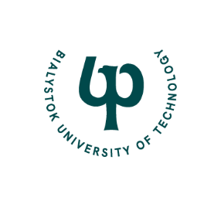
ORGANIZERS PATRONAGE
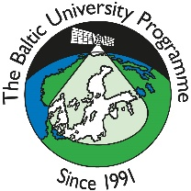
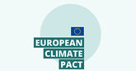
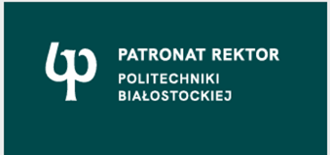

“The Role of University and Research for Sustainable Regional Development”
International Scientific Symposium for Baltic University Programme (BUP) participants
(Researchers, PhD students, administrative staff)
Host Institution: Bialystok University of Technology (BUT), Poland

April 21, 2024 (Sunday)
17:00 – 17:30 | Registration at the hotel
17:30 – 19:00 | Tour of Bialystok, looking at examples of green urban infrastructure
19:00 | Dinner, Kwestia Czasu (Akademicka 26A)

April 22, 2024 (Monday)
8:30 | Organized transport, meeting point - bus stop nr 303 Al. Piłsudskiego/Sienkiewicza street
9:00 – 13:00  Presentations  Coffee Break  Poster Session | Opening of symposium, CNK Building at BUT campus - 16 Zwierzyniecka St., Aula 33  Plenary session I -Theories of Sustainable Development  Moderator: Dorota Gawryluk  Authors of presentations are required to arrive 15 min prior to the session
Ireneusz Zbiciński  ONLINE | Lodz University of Technology, Poland  Introduction to Baltic University Programme and the Circular Economy
Lisa Wälitalo | Blekinge Institute of Technology, Sweden  RESPONSE – an approach for a faster transition to sustainable development through regional networks
Mariana Ruda | Lviv Polytechnic National University  "Circular economy in EU: opportunities and challenges for green recovery of Ukraine"
Inguss Vircavs | University of Latvia  Development challenges through the application of the competitive neutrality principle in Latvia
Veronika Dmytruk  ONLINE | Lviv Polytechnic National University, Ukraine  Sustainable Society Course Development: Poland Case Study
Loreta Kelpšaitė-Rimkienė | Klaipeda University, Lithuania  Sustainable port management for the sandy beach
10:30 – 11:00 | Coffee break
11:00 – 12:30 | Representatives from Bialystok University of Technology present the University Strategy for Sustainable Development
13:00 – 15:15 | LUNCH and meeting with local government officials in City Center
15:30 – 17:00 | Plenary session II (CNK Building at BUT campus - 16 Zwierzyniecka St.) Aula 33  Trends and Directions in SD on a National Level  Moderator: Lukasz Nazarko
Khrystyna Barvinska | Lviv Polytechnic National University, Ukraine  Influence of Transport on the City Ecosystem
Bokai Liu | Umeå Universitet, Sweden  Multi-scale and Multi-tier energy efficient framework for sustainable buildings with PU-Phase Change Materials in Northern Sweden
Artur Amsharuk | Bialystok University of Technology, Poland  Searching for locations for the construction of new wind farms in Poland using GIS and MCDA
Kaisa Helttunen | University of Jyväskylä, Finland  Organic chemistry for circular economy
Lukasz Nazarko | Bialystok University of Technology, Poland  Bialystok University of Technology research and innovation activity through the lense of Sustainable Development Goals
Ali Mammadzada | University of Warsaw, Poland  Baku Green Guardians: "Mobilizing Urban Citizens for Climate Resilience"
19:00 | Dinner in City Center, Restaurant Kawelin (10 Legionowa Street)

April 23, 2024 (Tuesday)
8:30 | Organized transport, meeting point - bus stop 303 Al. Piłsudskiego/ Sienkiewicza street Please take your luggage with you
9:00 – 10:30  Presentations  10:30 – 12:00  Poster Session | Plenary session III: “My Green University”: ESG Best Practices  (CNK Building at BUT campus - 16 Zwierzyniecka St.) Aula 33  “My Green University” https://pb.edu.pl/moja-zielona-politechnika/en/  Moderator: Anna Werner – Juszczuk  Authors of presentations are required to arrive 15 min prior to the session
Uğur AKBABA | Kafkas University, Turkey  Increasing the CO2 Storage Capacity of Carbon-Based Materials
Samson Fasogbon | University of Ibadan, Nigeria  Looped Love Hertzs-Mosquito Killing Device
Aniela Staszewska | Bialystok University of Technology  Education for Sustainable Development Based on the Baltic University Programme
Nomeda Gudelienė | Mykolas Romeris University, Lithuania  The Role of Universities in Building Sustainable Cities and Communities: The Case of Mykolas Romeris University, Lithuania
Oleksandra Khalaim | Uppsala University  While Playing to Change the World: Theater and Gaming Techniques in Sustainability Teaching
10:00 – 10:30 | Coffee break
Marta Sosnowska | Bialystok University of Technology, Poland  Sustainable Development Models at Higher Education Institutions
Agnieszka Sakowicz | Bialystok University of Technology, Poland  Sustainable development of doctoral schools in Poland
Mariana Senkiv | Lviv Polytechnic National University  Wikipedia educational program at the university as an important tool for sustainable development
10:30 – 12:00 | Brainstorming session – advice from participants about the directions the university can take to be more sustainable, suggestions participants can take back home to their institutions, Moderator: Aniela Staszewska
12:00 – 13:00 | LUNCH, CNK Building
13:00 – 15:00 | Tour of Laboratories and the Civil Engineering Department of BUT  Concrete Technology and Recycling Laboratory, Assoc. Prof. Katarzyna Kalinowska-Wichrowska  Building Construction Laboratory, Assoc. Prof. Marcin Gryniewicz  Alternative Energy Sources Laboratory, Assoc. Prof. Piotr Rynkowski  Laboratory of heating systems, Assoc. Prof. Anna Werner - Juszczuk
 | End of Baltic University Programme (BUP) event
Programme is subject to change
Participants can choose to stay on to enjoy BUT’s International Staff Week at an additional cost.
12th International Staff Week 2024 | IMOTION (staffmobility.eu)

