Dear student!

Do you have a problem logging in to Office 365 or Eduroam?
If you have not received a message from the University Information Center, before contacting us, check the SPAM folder, perhaps the message was there.
Where to find the data for the first login in Office365?
The data for logging in to Eduroam is also the data for the first logging in to OFFICE365 (portal.office.com).
To learn this information, log in to USOSweb (https://usosweb.pb.edu.pl/ - with the username and password our IRO office sent you) and check the new login details in the "My USOS" tab.

The above changes are due to the care for the appropriate level of security of your data.

Instruction for Eduroam

- Step 1
Log in to: https://usosweb.pb.edu.pl/
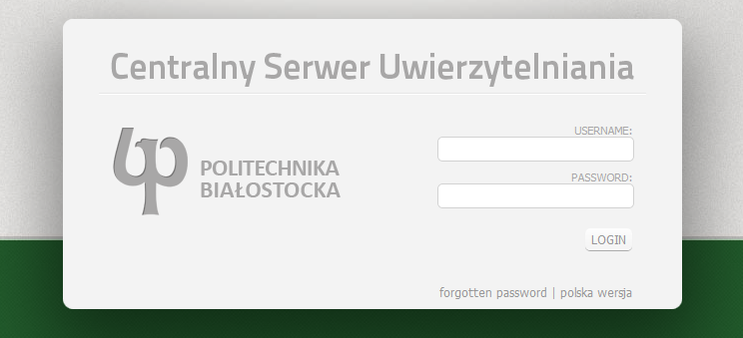

- Step 2
Introduce the code you received at Erasmus office
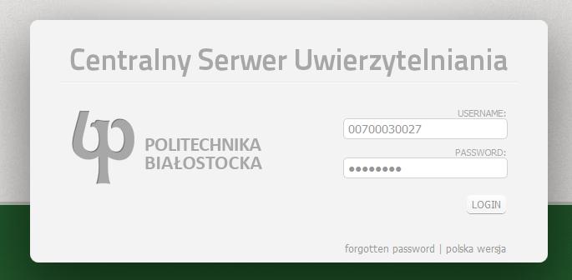
- Step 3
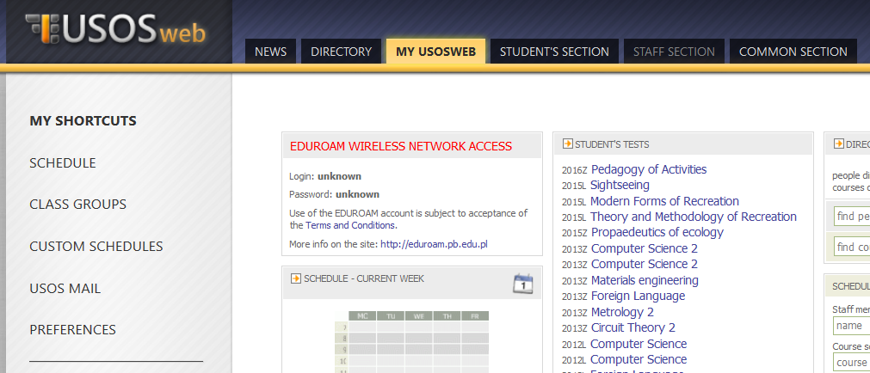
In the section “My USOSWEB” (in red), you will find your username and password for WiFi in the campus and also to access the computers at the CNK building (the library).

