DEAR STUDENTS/ GUESTS,

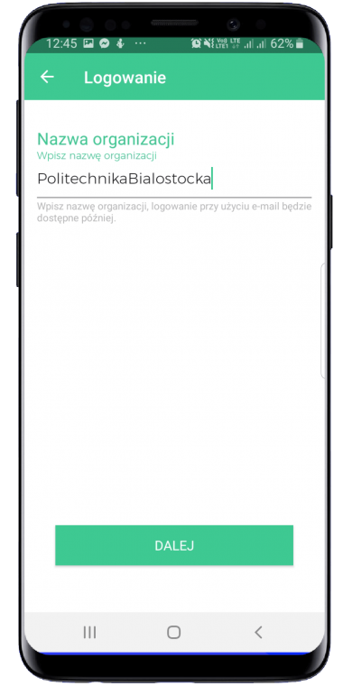
Zonifero - is a virtual map that makes it easier to navigate the Bialystok University of Technology! Install the Zonifero app on your phone and find yourself in the university spaces.

- CHOICE OF ORGANIZATION

After switching on the application and clicking on the "Login" button, enter the name of the university: "PolitechnikaBialostocka" (together with no Polish characters).

- ACCEPTANCE OF THE REGULATIONS AND SELECTION OF USER'S ROLE
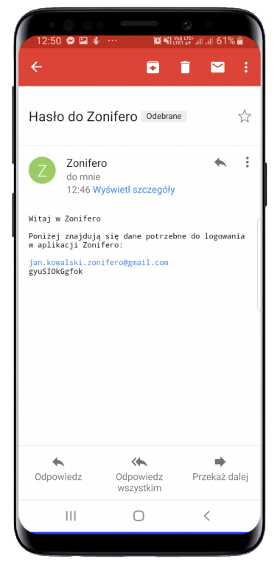
Log in as STUDENT / GUEST and accept the regulations.
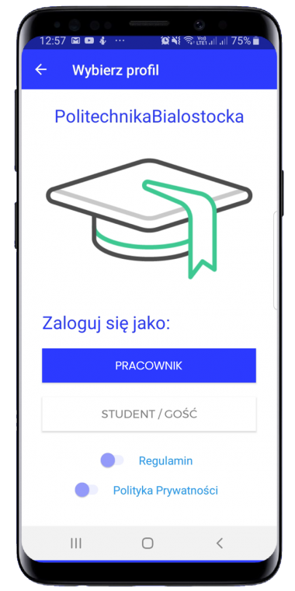

- E-MAIL ADDRESS AND PASSWORD FOR ACCOUNT

Now enter and approve the e-mail address. After acceptance, log in to your email, that's where the message with the generated password was sent.

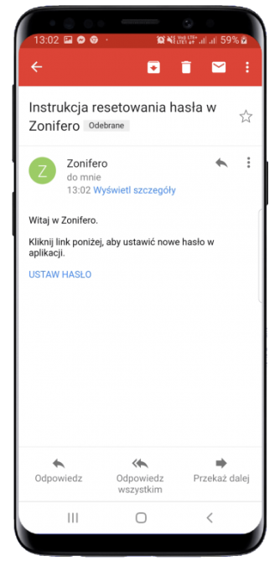

- COMPLETING THE PROFILE

Check if the profile data is correct. Possibly correct the errors or fill in the information.

- MAIN VIEW OF THE AREA

After completing the profile, the application will redirect you to the main application view.
Area at the Bialystok University of Technology:
- Center for Modern Education,
- All faculties in the campus at Wiejska Street,
- Faculty of Engineering Management,
- Faculty of Architecture
- Faculty of Forestry.

* To switch between areas, drag your finger over the photo or click the arrow on the right and / or left of the photo.
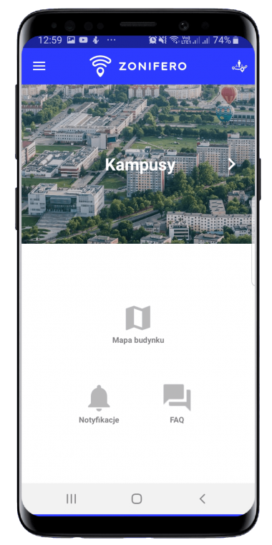

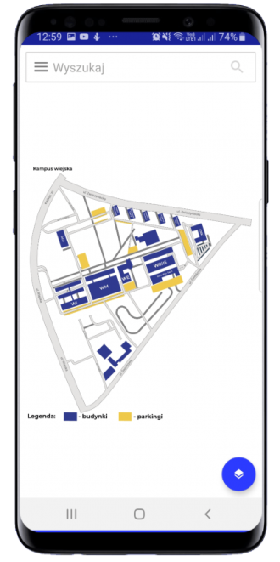

- MAP VIEW

The application allows users to view maps made on the basis of site plans. The map view also contains a search engine for defined rooms or other elements within the area. The button in the bottom right corner of the screen allows you to switch between maps / floors in your area.

- FAQ

This is a university guide for students. At the same time, a collection of answers to frequently asked questions. Each area, departments, campus or CNK has its own defined FAQ.
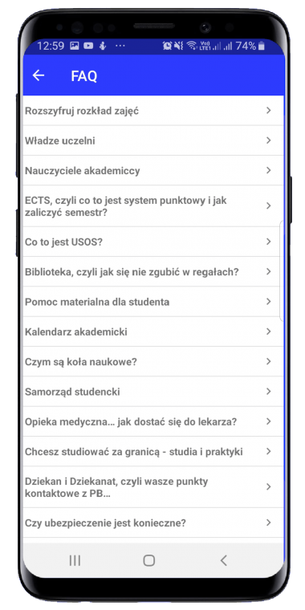

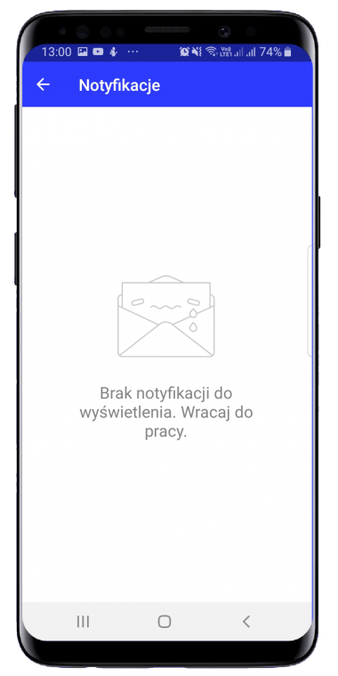

- NOTIFICATIONS

These are messages that you can receive from the university authorities or student government. They can refer to rector hours or events.

